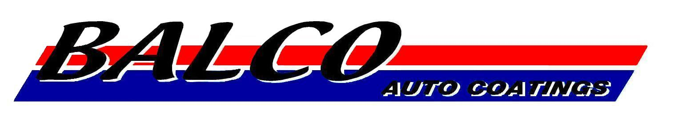
1 March 2010
TO WHOM IT MAY CONCERN

We confirm that Ladysmith Panelbeaters utilise the PPG Refinish System in the repair of vehicles. More specifically they are using the very latest state-of-the-art techonology in the PPG Envirobase HP waterbased system. PPG is a leading automotive refinish worldwide brand with two out of every three cars world wide having a PPG product. PPG Refinish products are classed as prime quality refinishing products with leading edge technology, superb colour matching performance and extreme ease of use.

The trend worldwide is towards environmentally friendly water based systems. PPG has been developing refinish water based systems for over 30 years and the latest technology (ENVIROBASE HP) is a third generation system. PPG is recognised as the undisputed leader in water based technology with significant approvals with most of the OEM’s including Daimler, Toyota, Chrysler, General Motors, Volvo and VW.

The advantages of PPG Envirobase HP are:

The system is extremely stable. This is evident from the fact that it requires no “mixing bench” and no special storage. This is a true “pick-up, shake and pour” system which no other brand can match.

The system achieves drying times which are equal if not better than solvent borne systems. This is achieved in a standard unmodified booth.

The system has superior colour matching performance so much so that “panel-to-panel” painting is the norm. No other system can match this performance.

The system is extremely user friendly and spray painters adapt to its use very quickly.

In addition to using World Class products from PPG, Ladysmith Panelbeaters is regularly audited by the Balco Auto Coatings technical staff to ensure that the paint rectification processes are efficient and meet PPG standards. Ladysmith Panelbeaters consistently perform to the highest paint rectification standards and meet the conditions for a PPG Approved Collision Repair Centre.

Yours faithfully,
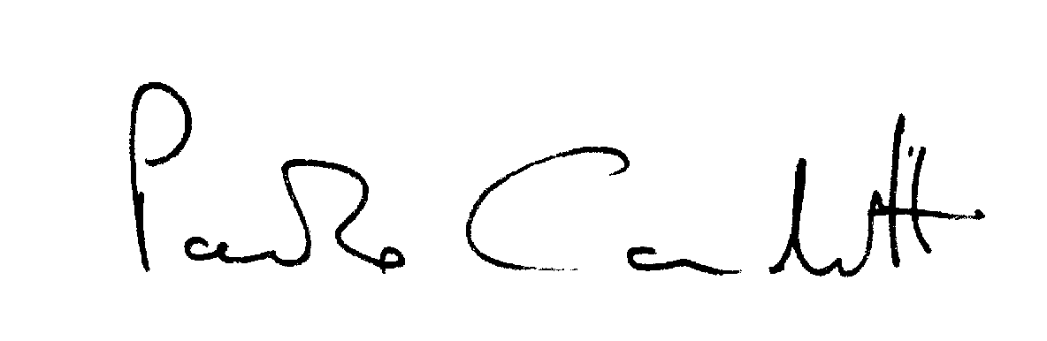

Paolo Candotti
Director: P A Candotti

BALCO AUTO COATINGS KZN (PTY) LTD. Co. Reg. No. 2002/005175/07
PO Box 49258 Tel: 031 332 1110 38 Morrison Street, Durban
East End Fax: 031 332 1210 236 Greyling Street, Pietermaritzburg
4018 11 Thompson Road, Ladysmith
9F Platina Drive, Empangeni

